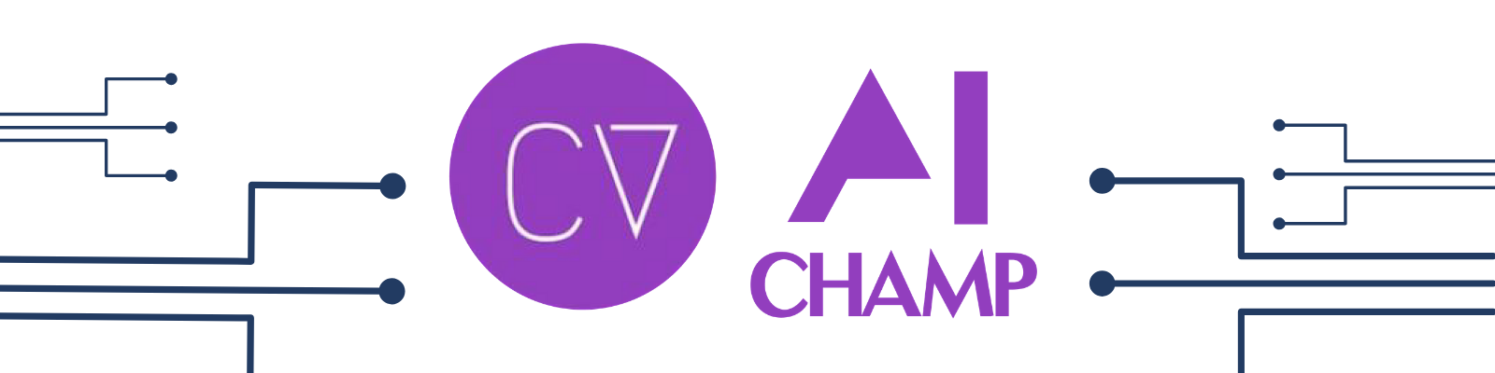

**Screening Test**

short line

Tasks

1. To implement a solution to make sure that Standard Operating Procedures are followed in manufacturing factories.
   1. Detect whether workers are **wearing helmets** and send real-time information about defaulters.
   2. Detect if anyone is near a **restricted working space** and trigger an alarm.
   3. Detect if specified **doors are closed** and trigger an alarm in case of malfunction.
2. Create a document that contains all the necessary content to help someone read and implement the same solution.

Details

**Task 1**

You can use the dataset that is publicly available. However, for some cases, you might want to create some dataset on your own. This task is heavily based on your computer vision and coding skills. Try to complete a, b, and c part but its still fine if you submit any part of the task.

**Task 2**

You have to write the document with all the basic content that is required for someone to read and complete the task. For example, consider that you use object detection for helmet detection. Try providing the details like -

1. What type of object detectors are there?
2. What are some SOTA methods available?
3. What are the datasets that are publicly available?
4. Can we create our own dataset?
5. What are some software or techniques that we can use to label the dataset?
6. Has someone done similar work in this area?
7. What are some open-source codebases that people reading the document can refer to?
8. Provide more links to blogs, articles, videos, etc. to learn more about the topic.

Timeline

***The marathon starts from 4th September 2020 and shall conclude on 10th September 2020 (7 days).***

Assessment

Each of the tasks shall have a specific score.

The most critical parameters while scoring is:

1. Frequency of commits on GitHub (use git CLI).
2. Quality of your code.
3. The way you demonstrate your solution.
4. How well you maintain your documentation.
5. How well you’re able to explain things in the document of task 2.

As you have to mentor students, the interview process will be taken once you are through the screening processes. Mostly how well you’re able to explain things is important.

Note: ***If you’re not able to complete all the tasks, that is fine because most of the people won’t be able to. Submitting whatever half the work you do is still better. At least you have some chance this way. Those who don’t submit the task have zero chance of selection anyway.***

***All time in IST (+5:30 GMT)***

short dash

1. **What type of object detectors are there?**
2. Fast AI object detection has been used with anotated dataset (using PASCAL VOC ) to extract hats
3. Histogram of Oriented Gradient (**HOG**) feature descriptor is popular for object detection
4. Convolutions.

1. **What are some SOTA methods available?**
2. RetinaNet :

The RetinaNet is a one-stage object detector, meaning that the localization and classification tasks are done at the same time. The main contribution given by FAIR is the loss function of the network: The Focal Loss. Lower loss is contributed by “easy” negative samples (bounding boxes where there is no object) so that the loss is focusing on “hard” positive samples (bounding boxes that actually contains boxes). The focal loss solves the class imbalance issue of one-stage detectors :

This network consist of :

* A feature extractor (usually CNN) to obtain a feature map of the whole image. We used a Resnet101 pretrained on ImageNet as backbone.
* A feature pyramid network (FPN) to obtain high-level features at each scale, in order to get objects from different sizes and shapes. It uses skip-connection to establish a link with the layers from the backbone.
* 2 sub networks: One that classifies the bounding-boxes at each level and another that gets a more precise version of their coordinates

1. **What are the datasets that are publicly available?**
2. hard-hat-detection
3. haarcascades
4. lfwpeople
5. My-training
6. **Can we create our own dataset?**

We can create our own dataset using vedio scene for face detection .

1. **What are some software or techniques that we can use to label the dataset?**

Pascal Voc , haarcascades

1. **Has someone done similar work in this area?**

Yes , lots of work has been done and links are attached for same in next answer.

1. **What are some open-source codebases that people reading the document can refer to?**
   1. <https://github.com/topics/helmet-detection>
   2. <https://pythonawesome.com/helmet-detection-on-construction-sites/>
   3. <https://www.mathworks.com/matlabcentral/fileexchange/72381-helmet-detection-by-deep-learning>

1. **Provide more links to blogs, articles, videos, etc. to learn more about the topic.**
   1. <https://www.fast.ai/>
   2. <https://www.researchgate.net/publication/344109522_Live_Helmet_Detection_System_for_Detecting_Bikers_without_Helmet>
   3. <https://medium.com/@vijaysingh_60587/train-your-own-custom-model-for-helmet-detection-object-detection-using-yolo-f53a48066d7a>

Warm Regards

Nidhi